Databricks Data Engineer Mini Project: Daily, Weekly and Monthly Sales Report
This document records how I built the sales reporting notebook in Databricks, how the dropdown drives the report, and the results it produced.

1. Requirement
Sales data arrives as a CSV file. The business wanted to be able to pull a report for three different periods without anyone editing code each time:
- Daily, meaning yesterday
- Weekly, meaning the last seven days up to yesterday
- Monthly, meaning the first of the month up to yesterday
The report had to appear on screen and also be written out as a CSV dump. The notebook needed a dropdown so the user picks the period and the correct report runs.
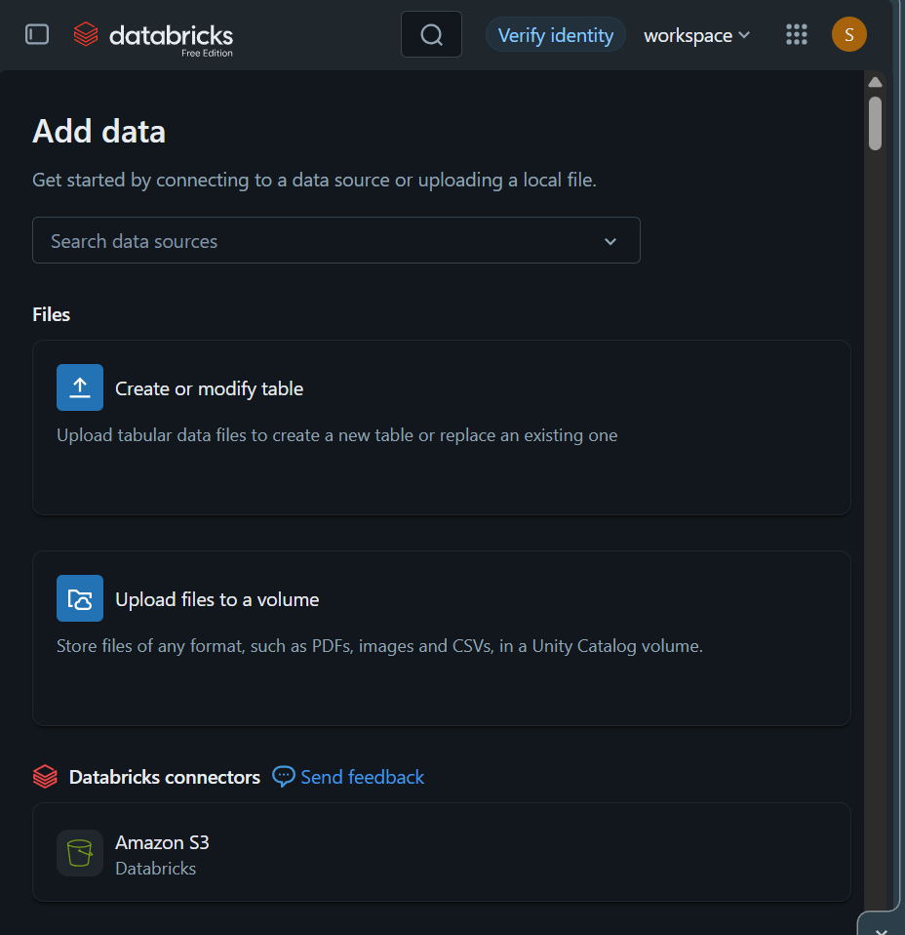
The Add data page. Free Edition does not offer the old DBFS upload, so I used Upload files to a volume.
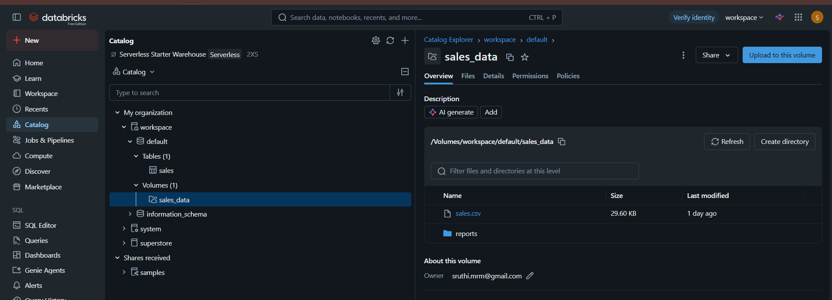
The sales_data volume holding the source file. The reports folder was created later by the notebook.

4. Reading the file
file_path = "/Volumes/workspace/default/sales_data/sales.csv"

sales_df = (
spark.read
.format("csv")
.option("header", "true")
.option("inferSchema", "true")
.load(file_path)
)

sales_df.printSchema()
display(sales_df)
header tells Spark the first row holds column names rather than data. inferSchema makes Spark read the file once to work out the types, so sale comes back as an integer and date as a proper date rather than everything being text.
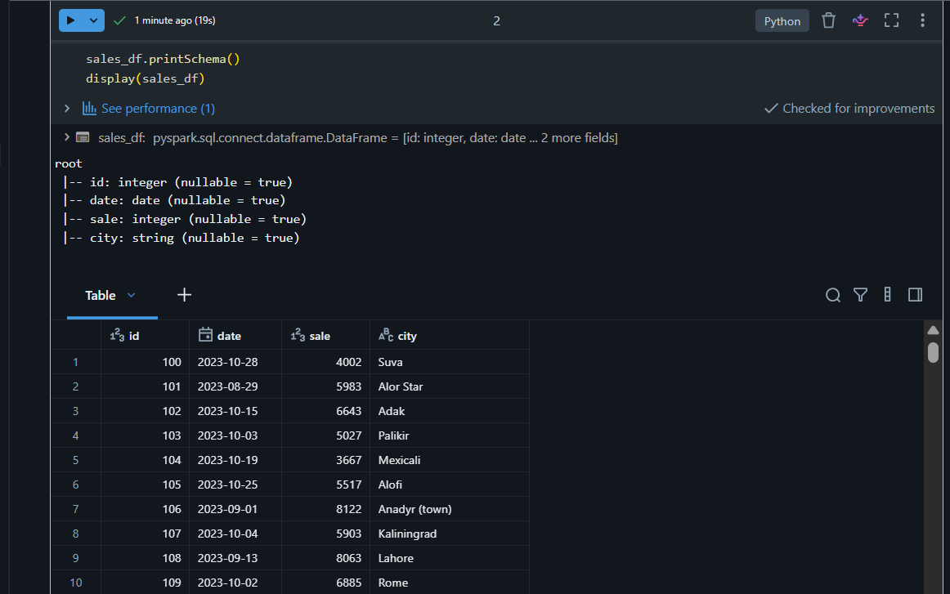
1,000 rows loaded. date came through as a date type, which matters later because the report compares dates rather than strings.

5. Saving to a Delta table
The CSV is the raw drop. Everything after this point reads the table instead of the file, which is how a real pipeline works: land the file once, then query the table.
table_name = "workspace.default.sales"

sales_df.write \
.format("delta") \
.mode("overwrite") \
.saveAsTable(table_name)
mode overwrite means the cell can be re-run without failing or duplicating rows.
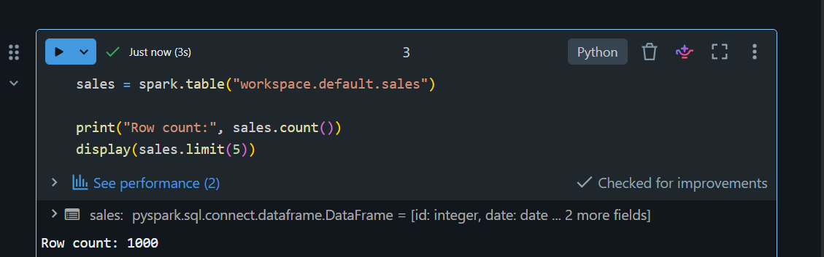
Reading the table back to confirm all 1,000 rows are there.

6. The widgets
A widget is an input control that appears at the top of the notebook. The user picks a value there instead of editing code. I created two.
dbutils.widgets.removeAll()

dbutils.widgets.dropdown(
name="frequency",
defaultValue="Daily",
choices=["Daily", "Weekly", "Monthly"],
label="Report Frequency"
)

dbutils.widgets.text(
name="run_date",
defaultValue="2023-11-11",
label="Run Date (yyyy-MM-dd)"
)
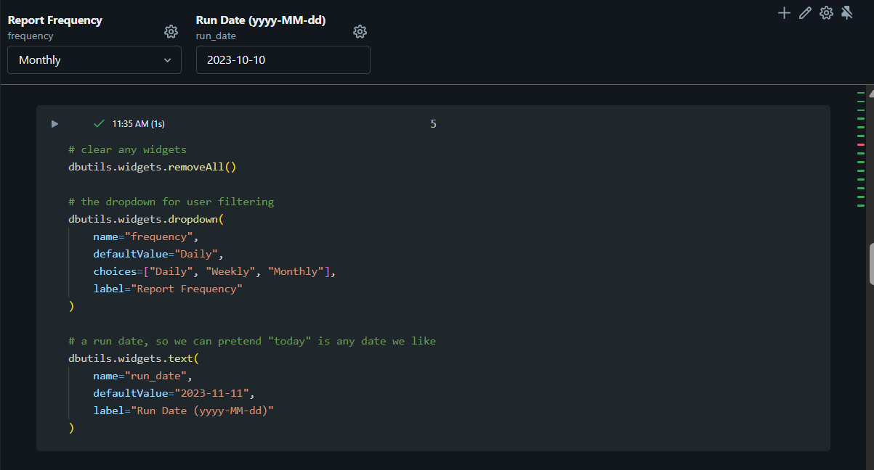
The widget definitions and the two controls they produce at the top of the notebook.
The second widget needs an explanation. The requirement says daily means yesterday, but this dataset stops on 10 November 2023, so a real yesterday would return no rows at all. The run_date widget lets me say "treat this date as today". In a live job you would default it to the actual current date instead, and nothing else in the notebook would change.
frequency = dbutils.widgets.get("frequency")
run_date_str = dbutils.widgets.get("run_date")
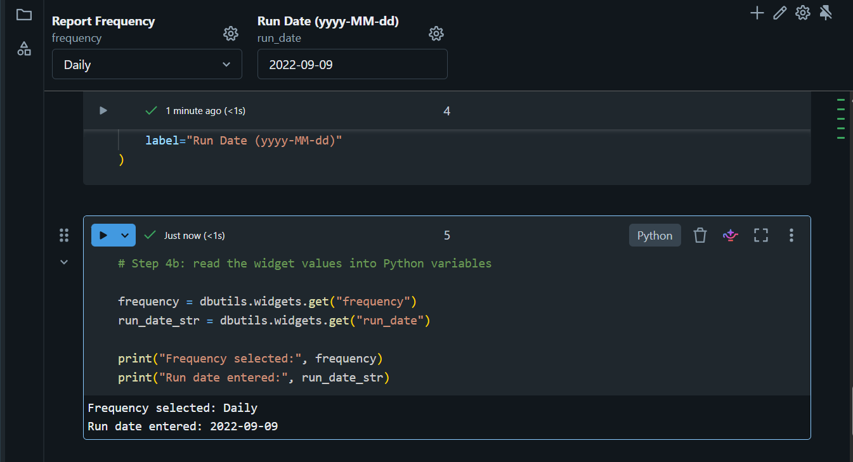
Reading the widget values back into Python variables. Widgets always return text, never a date.

7. Turning the choice into a date window
This is the only real logic in the notebook. The dropdown choice becomes a start date and an end date, and nothing after this point knows or cares which option was picked.
run_date = datetime.strptime(run_date_str, "%Y-%m-%d").date()

# the report always ends yesterday, because today is still incomplete
end_date = run_date - timedelta(days=1)

if frequency == "Daily":
start_date = end_date

elif frequency == "Weekly":
start_date = end_date - timedelta(days=6)

elif frequency == "Monthly":
start_date = end_date.replace(day=1)

else:
raise ValueError(f"Unknown frequency: {frequency}")
Three points on this:
- strptime converts the widget text into a real date. Widgets hand back text, so the conversion is required.
- end_date.replace(day=1) keeps the same year and month but sets the day to 1, which is the simplest way to get the first of the month without any calendar arithmetic.
- The else branch raises an error on purpose. If someone adds a fourth option to the dropdown later and forgets to add the matching logic here, the notebook stops rather than quietly producing a wrong report.
Frequency | Start date | End date
Daily | Yesterday | Yesterday
Weekly | Six days before yesterday | Yesterday
Monthly | First of yesterday's month | Yesterday

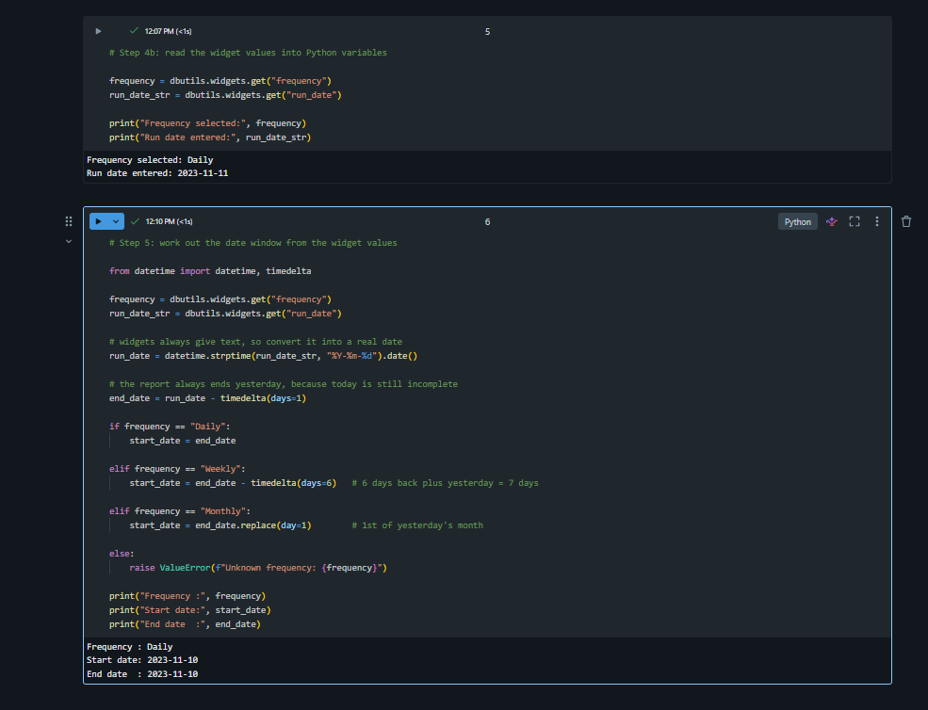
The Daily run with a run date of 2023-11-11. Start and end are both 2023-11-10.

8. Filtering and aggregating
This cell never changes, whichever period is chosen. It only reads the two date variables.
report_df = (
sales
.filter((col("date") >= start_date) & (col("date") <= end_date))
.groupBy("city")
.agg(
spark_sum("sale").alias("total_sales"),
count("*").alias("number_of_orders")
)
.orderBy(col("total_sales").desc())
)
Two things worth noting. sum is imported as spark_sum because Python already has a built in sum and the clash causes confusing errors. The filter uses round brackets around each condition and a single ampersand, because PySpark does not accept the Python keyword and.
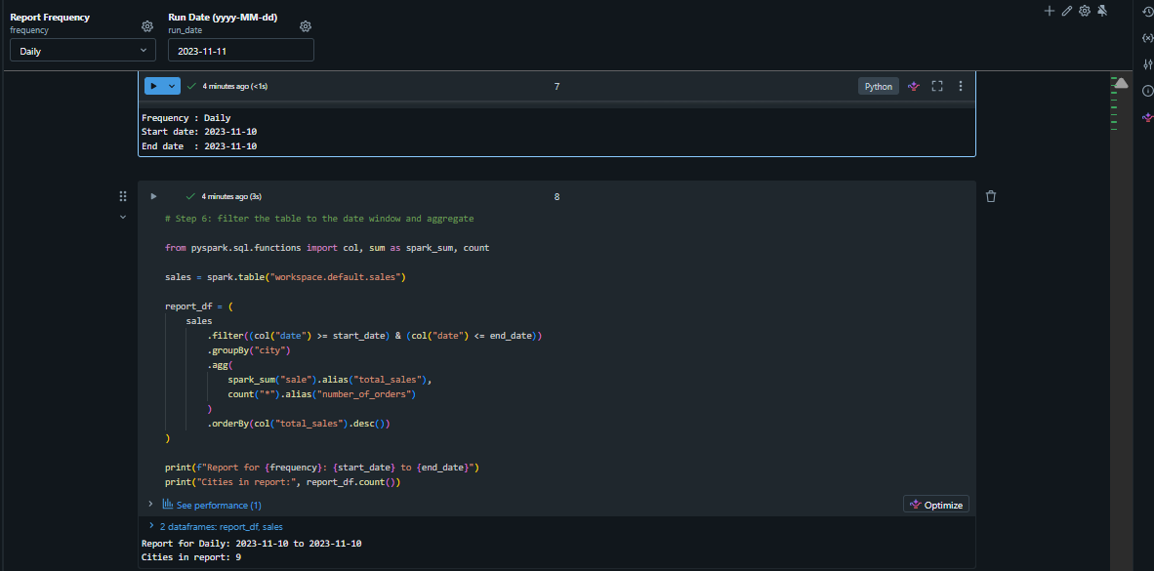
The Daily report. Nine cities had sales on 10 November 2023.

9. Displaying the report
display(report_df)
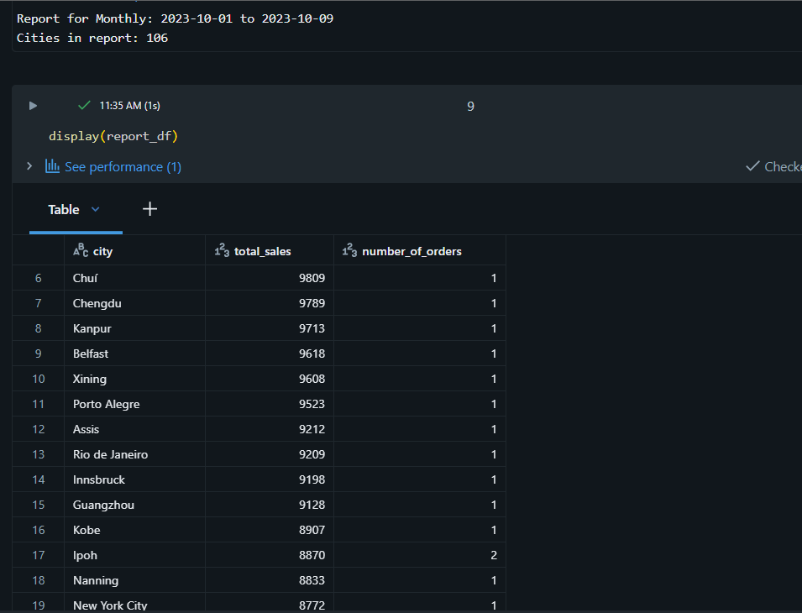
The Monthly run, with a run date of 2023-10-10, giving a window of 2023-10-01 to 2023-10-09 and 106 cities. Same cell, same query, different date window.

10. Writing the CSV dump
The output path is built from the frequency and the end date, so each run is traceable and re-running the same report replaces it rather than piling up copies.
output_path = (
f"/Volumes/workspace/default/sales_data/reports/"
f"{frequency.lower()}/{end_date}"
)

report_df \
.coalesce(1) \
.write \
.mode("overwrite") \
.option("header", "true") \
.csv(output_path)
coalesce(1) forces a single output file. Spark writes in parallel by default, so without it you get several part files. That is fine for a small report like this one, but on a large dataset you would not do it, because it pushes all the data through one worker.
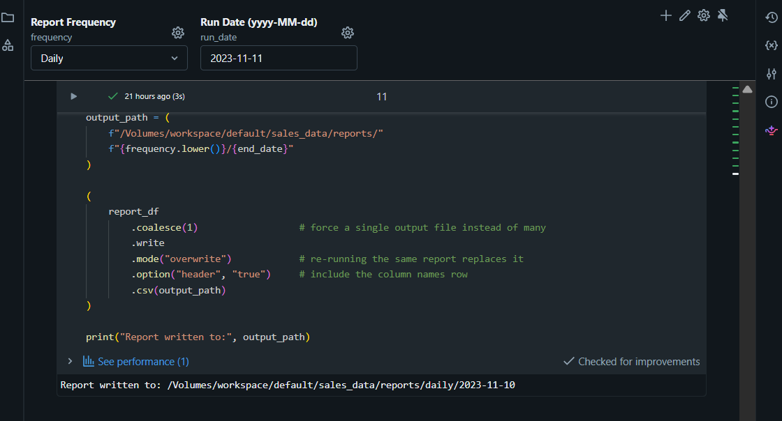
The Daily dump written to reports/daily/2023-11-10.
Spark writes a folder, not a single file. The folder contains the part file plus _SUCCESS and commit markers.
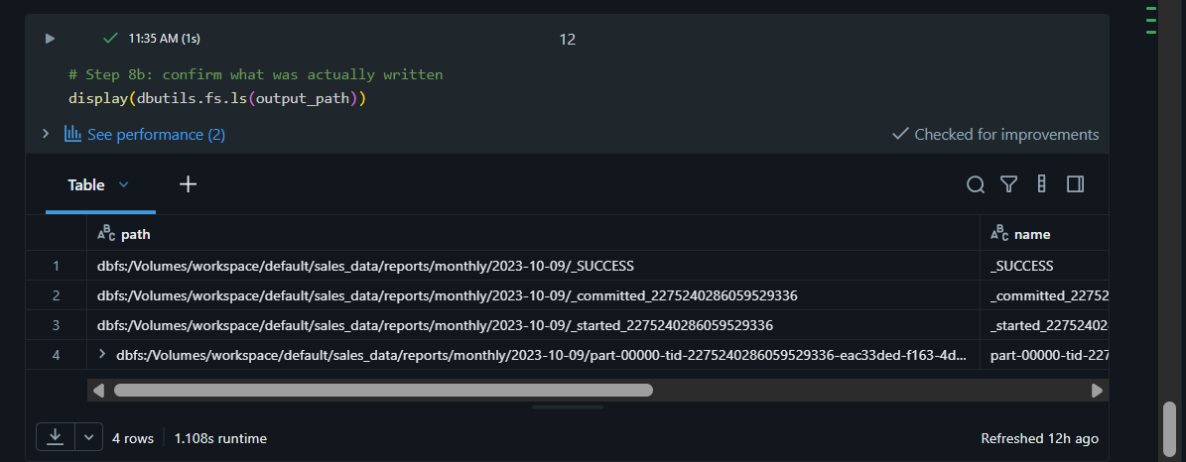
The contents of the Monthly output folder, showing the part file and the _SUCCESS marker.
Since a folder full of part files is awkward to hand to someone, I added a step that copies the part file out under a readable name.
files = dbutils.fs.ls(output_path)
part_file = [f.path for f in files if f.name.startswith("part-")][0]

final_file = (
f"/Volumes/workspace/default/sales_data/reports/"
f"sales_report_{frequency.lower()}_{end_date}.csv"
)

dbutils.fs.cp(part_file, final_file)

11. Testing the three options
Changing the dropdown does not re-run anything on its own. The widget value is only read when the date window cell runs, and every cell after that uses whatever start and end dates were last calculated. So after switching the dropdown I used Run all below from the date window cell.
Frequency | Run date used | Window produced | Cities
Daily | 2023-11-11 | 2023-11-10 to 2023-11-10 | 9
Monthly | 2023-10-10 | 2023-10-01 to 2023-10-09 | 106

The city count rising from 9 to 106 is the check that the window is genuinely changing. If the three options returned the same count it would mean the cells had not re-run in order.
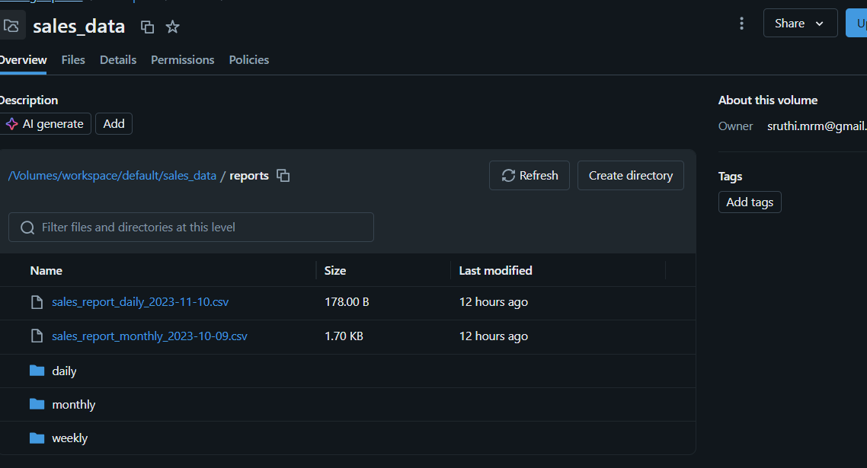
The reports folder after running all three options. There is a folder per frequency, plus the named single file copies.

